Network limitations: The company's LAN, primarily used for emails, printing, and browsing, may have limitations in terms of bandwidth or scalability, which can impact the performance of the new system

Table of Contents

Request for System Services 4

Problem Statement Matrix 5

MS Project 6

Ishikawa Diagram 7

Functional and Non-Functional Requirements 8

Actor Glossary 11

Use Case Glossary 12

Analysis Use Case Model Diagram for whole system 13

Analysis Use Case Narrative 14

Request Donation – Noora Qasim 14

Request Volunteers – Maryam Salah 16

Create New Project – Maryam Aqeel 18

Registration/Sign Up – Fatima Naser 20

Activity Diagram 22

Request Donation – Noora Qasim 22

Request Volunteers – Maryam Salah 23

Create New Project – Maryam Aqeel 24

Registration/Sign Up – Fatima Nasser 25

Potential Object List 26

Proposed Object List 28

Analysis Domain Class Diagram for whole system 29

Cost/Benefit Analysis 30

Net-Present Value 30

Payback Period 31

State-chart Diagram 32

Project – Maryam Aqeel 32

Task – Fatima Nasser 32

Volunteer – Maryam Salah 33

Donation – Noora Qasim 33

Sequence Diagram 34

Request Donation – Noora Qasim 34

Request Volunteers – Maryam Salah 35

Create New Project – Maryam Aqeel 36

Registration/Sign Up – Fatima Nasser 37

Interview Form 38

Log Files 40

Log 1 40

Log 2 41

Log 3 42

Log 4 43

Log 5 44

Log 6 45

Log 7 46

Log 8 47

Individual Report 48

Fatima Naser – 202102290 48

Maryam Aqeel – 202103328 50

Maryam Saleh – 202100106 52

Noora Qasim – 202103422 54

# Request for System Services

|  |  |  |  |
| --- | --- | --- | --- |
| https://lh5.googleusercontent.com/sdpeEo3wGEhEps9AsgX3tuzMAGRdfdvnutHZC6QxdpbbnF4GB-u1DUZkpfCRgDPHq_eUtvkj5GDlHRSLbBngnP9XpBlrEenvUUW_LrkUE3YpuVPQK6E2zP8ZrXrlgK02Kl_JGkH9Ob3AWzxsPt3IQEaQ7g_fEU0Bn7wyaSOvcQGfP5WaEFiYTQSiGg6A-ONO | **Bahrain Trust Foundation**  Phone: Fax: | |  |
| **DATE OF REQUEST** | | **SERVICE REQUESTED FOR DEPARTMENT(S)** | |
| 10/13/2022 | |  | |

|  |  |
| --- | --- |
| **SUBMITTED BY (key user contact)** | **EXECUTIVE SPONSOR (funding authority)** |
| **Name** | **Name** |
| **Title** | **Title** |
| **Office** | **Office** |
| **Phone** | **Phone** |

**TYPE OF SERVICE REQUESTED:**

Information Strategy Planning  Existing Application Enhancement

Business Process Analysis and Redesign  Existing Application Maintenance (problem fix)

New Application Development  Not Sure

Other (please specify **_______________________________________________________________________**

|  |
| --- |
| **BRIEF STATEMENT OF PROBLEM, OPPORTUNITY, OR DIRECTIVE (attach additional documentation as necessary)**  Redundant information in the Bahrain Trust Foundation, causing difficulty in processing projects, extreme project delays. To find and contact appropriate donors and volunteers is a lengthy and tedious project that takes a lot of time. Cannot produce effective reports hence no progress to the better in the foundation. |

|  |
| --- |
| **BRIEF STATEMENT OF EXPECTED SOLUTION**  **New web based solution with a built in DBMS software along with customized dashboard for each user type** |

|  |
| --- |
| **ACTION (ISS Office Use Only)**  **Feasibility assessment approved Assigned to Karak**  **Feasibility assessment waived Approved Budget __3000BHD___________   Start Date _13/10/2022 _____ Deadline _20/12/2022 ___**  **Request delayed Backlogged until date: ______________**  **Request rejected Reason: ________________________________________________**  **Authorized Signatures: ___________________________________ ________________________________________________   Project Executive Sponsor** |

# Problem Statement Matrix

|  |  |
| --- | --- |
| **PROJECT: Web based sol** | **PROJECT MANAGER: Mr. X** |
| **CREATED BY: Karak team** | **LAST UPDATED BY: Karak team** |
| **DATE CREATED: MM/DD/YYYY** | **DATE LAST UPDATED: 11/17/2022** |

|  |  |  |  |  |  |
| --- | --- | --- | --- | --- | --- |
| **Brief Statements of Problem, Opportunity, or Directive** | **Urgency** | **Visibility** | **Annual Benefits** | **Priority or Rank** | **Proposed Solution** |
| 1. Incapable of including the number of new projects | 10 weeks | High | - | 1 | New web-based solution |
| 1. Inefficient process, not enough insightful reports | 10 weeks | High |  | 1 | New web-based solution |
| 1. Incapable of storing or maintaining data | 10 weeks | High |  | 1 | New web-based solution |
| 1. Automate communication with donors and volunteers | 10 weeks | High | 4 hours of overtime a week | 2 | New web-based solution |
| 1. Customized dashboard/portal | 10 weeks | High |  | 2 | Customized dashboard in New web-based solution |
| 1. No DBMS software | 10 weeks | High | 5% efficiency increase | 1 | New web-based solution |
| 1. No ADE | 10 weeks | High | 5% efficiency increase | 1 | New web-based solution |

# MS Project

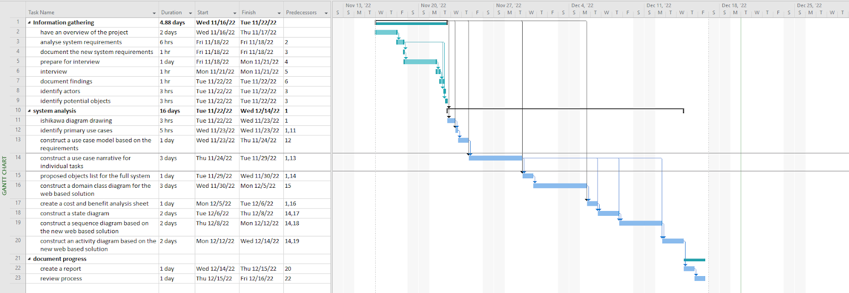

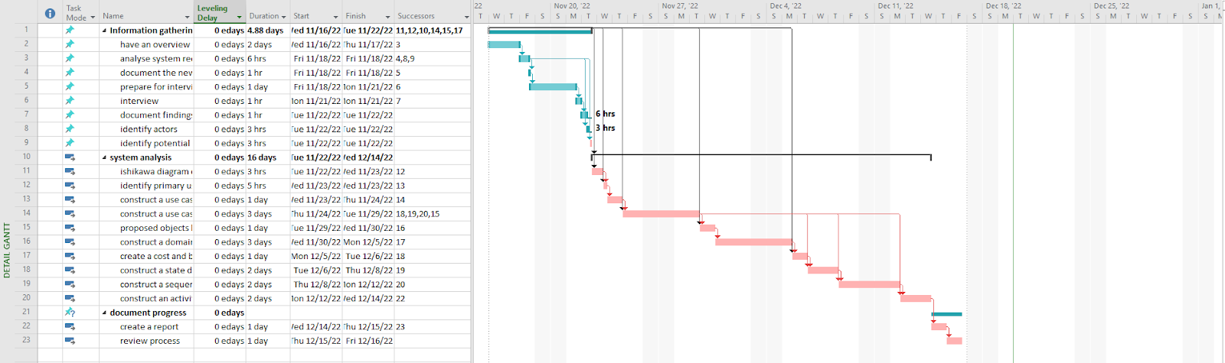

# Ishikawa Diagram

# Functional and Non-Functional Requirements

**Requirements Traceability Matrix**

|  |  |
| --- | --- |
| **PROJECT: BTF system** | **PROJECT MANAGER: Mrs. Saba** |
| **CREATED BY: Karak Team** | **LAST UPDATED BY:** **Fatema Naser** |
| **DATE CREATED: 2/11/2022** | **DATE LAST UPDATED: 22/12/2022** |

|  |  |  |  |  |
| --- | --- | --- | --- | --- |
| **No.** | | **Source** | **Description**  **Follow the PIECES Framework** | **Type**  **Functional**  **Non Functional** |
| 1 | Project  brief | Customized dashboard for each user | F |
| 2 | Project  brief | Store, process and maintain data on overall projects, donors and volunteers including reports, surveys and agreements | NF |
| 3 | Project  brief | Automate communication with donors and volunteers and the selection in regard to urgent cases | NF |
| 4 | Project  brief | Make use of the Ethernet tcp/ip network | NF |
| 5 | Project  brief | Contains a database management system and an ADE | NF |
| 6 | Project  brief | Automates business processes to increase efficiency. Discards repetitive tasks | NF |
| 7 | Project  brief | Handles multiple types of users | NF |
| 8 | Project  brief | Users register to their accounts on web portal | F |
| 9 | Project  brief | Each user has a unique username and password | NF |
| 10 | Project  brief | Verifies user credentials by contacting admin | NF |
| 11 | Project  brief | Sends email to confirm registration | NF |
| 12 | Project  brief | Display current and urgent projects with suggestive list of donors and volunteers for the employees | F |
| 13 | Project  brief | Contains a form to add a new project | F |
| 14 | Project  brief | Contacts project manager to approve projects | NF |
| 15 | Project  brief | Contains and displays active, completed and rejected projects | F |
| 16 | Project  brief | Search and filter projects by using different search criteria | F |
| 17 | Project  brief | Create a sponsorship package | NF |
| 18 | Project  brief | Create a marketing opportunity | NF |
| 19 | Project  brief | Communicate through email, WhatsApp message, SMS | NF |
| 20 | Project  brief | Donors can make partial or full payments | F |
| 21 | Project  brief | System checks on interested donors and send required information and a status update | F |
| 22 | Project  brief | Sends thank you emails for donations | F |
| 23 | Project  brief | Stores new donors in a donor database | NF |
| 24 | Project  Brief | Fetch and compile volunteer data | NF |
| 25 | Project  brief | Filter volunteers as per project requirements | NF |
| 26 | Project  brief | Check volunteer availability – call/text | F |
| 27 | Project  brief | Store, keep data for volunteers that wish to stay on communication channels | NF |
| 28 | Project  brief | Sends appreciation certificates to completed volunteers | F |

# Actor Glossary

|  |  |  |
| --- | --- | --- |
| **Actor Glossary** | | |
| **Actor Name** | **Actor Description** | **Actions done** |
| Volunteer | An external from the foundation that registered to take part in tasks | Perform task  Register within web portal |
| Donor | An external from the foundation that is interested in paying money to fund projects | Make payment  Register with web portal  View project information |
| Project coordinator | An internal employee of the foundation that is responsible of coordinating the project and their tasks | Adds new project  Fills project form  Registers with web portal  Manage project tasks |
| Project manager | An internal employee of the foundation that is responsible of managing the project | Register with web portal  Browse and filter projects  Approve new project |
| Admin | An internal employee responsible for the entire process | Register with web portal  Verify  Browse and filter projects |
| Financial accountant | An internal employee of the foundation that is responsible of the financing | Register with web portal  Browse and filter projects |

# Use Case Glossary

|  |  |  |
| --- | --- | --- |
| **Use-Case Glossary** | | |
| **Use-Case Name** | **Use-Case Description** | **Participating  Actors and Roles** |
| Register web portal | This use case will allow the user to enter into their web account | Volunteer, donor, project coordinator, project manager, administrative officer, financial accountant |
| Verify user credentials | This use case performs a verification process for the username and password written. | Null (the system) |
| Perform task |  | Volunteer |
| Receive appreciation certificate |  | Null (system) |
| Send activation link | This use case will send activation link if credentials are right. | Null (the system) |
| Browse and filter project | This use case will allow the user to search and look for projects. | Volunteer, donor, project coordinator, project manager, administrative officer, financial accountant |
| Make payments | This use case will allow the donor to make different type of payments | Donor |
| Full payment | This use case will allow the donor to make a full payment | Donor |
| Partial payment | This use case will allow the donor to make a partial payment | Donor |
| Send thank you messages | This use case will send thank you message to the donor once donated | Null (system) |
| View project information |  | Donor |
| Add new project |  | Administrative officer |
| Approve new project | This use case will verify and approve projects | Project manager |
| Send to pending approval list | This use case will send approved projects to approval list | Null (system) |
| Fill form | This use case will allow the project coordinator to add a project form | Project coordinator |
| Manage project task | This use case allow the project coordinator to manage the project tasks divided | Project coordinator |
| Add project | This use case allows the addition of a new project to the system | Project coordinator |
| Divide project | This use case allows the division of a new project in the system to smaller tasks | Project coordinator |

# Analysis Use Case Model Diagram for whole system

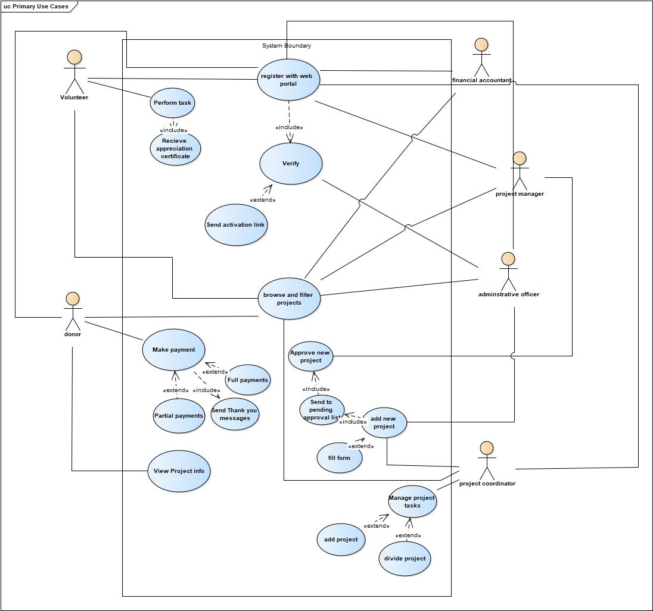

# Analysis Use Case Narrative

## Request Donation – Noora Qasim

**BTF**

**Author (s): Noora Wael Date: ___________**

**Version:** ___________

|  |  |  |  |
| --- | --- | --- | --- |
| **USE CASE NAME:** | Request Donation | | **USE CASE TYPE** |
| **USE CASE ID:** |  | | Business Requirements: **o** |
| **PRIORITY:** |  | | System Analysis: **þ**  System Design: **o** |
| **SOURCE:** |  | |  |
| **ACTORS** | System, donor | | |
| **STAKEHOLDERS:** | Project manager, project coordinator | | |
| **DESCRIPTION:** |  | | |
| **PRE-CONDITION:** | Project coordinator, adds project | | |
| **TRIGGER:** | Project manager approves project | | |
| **TYPICAL COURSE** | **Actor Action - donor** | **System Response - System** | |
| **OF EVENTS (FLOW OF ACTIVITIES):** | **Step**: | **Step 1**: prepare list of targeted donors and their contact information | |
|  |  | **Step 2:** invoke package creation use case | |
|  |  | **Step 3:** invoke marketing package use case | |
|  |  | **Step 4:** send message to targeted list of donors via WhatsApp/ SMS/Email | |
|  | **Step 5:** donor receives message and approves to pay payment |  | |
|  |  | **Step 6:** receives donor approval to pay | |
|  |  | **Step 7:** displays full project information screen | |
|  |  | **Step 8:** update donor status to “approved” | |
|  |  | **Step 9:** display payment options of partial or full payments to donor | |
|  | **Step 10:** donor chooses payment option |  | |
|  |  | **Step 11:** payment method page is displayed | |
|  | **Step 12:** donor makes payment |  | |
|  |  | **Step 13:** system invokes check payment use case | |
|  |  | **Step 14:** displays successful transaction information | |
|  |  | **Step 15**: update status of the project on database | |
|  |  | **Step 16:** update the donor status to paid on database | |
|  |  | **Step 17:** display thank you message on the screens | |
|  | **Step 18 :** View thank you message | **Step 19:** Send receipt on donor email | |
|  |  | **Step 20:** sends thank you message via donor social account | |
| **ALTERNATE COURSES (EXCEPTION CONDITIONS):** | **Step 4a:** if donor ignores, return to step 1 to pick a new one | | |
|  | **Step 5a:** if donor rejects return to step 1 to pick a new one | | |
|  | **Step 10a:** if donor chooses partial payment, complete payment and collect more donations, deduct amount from the amount left | | |
|  | **Step 13a:** if transaction is not successful, display failed message and return to payment page | | |
|  |  | | |
|  |  | | |
|  |  | | |
|  |  | | |
|  |  | | |
| **CONCLUSION:** | Money is received | | |
| **POST-CONDITION:** | Project is closed/ funded | | |
| **BUSINESS RULES** | Donor has to receive thank you message after paying | | |
| **IMPLEMENTATION CONTRAINTS AND SPECIFICATIONS** |  | | |
| **ASSUMPTIONS:** |  | | |
| **OPEN ISSUES:** |  | | |

## Request Volunteers – Maryam Salah

**< BTF >**

**Author (s): _____Maryam Salah__________ Date: ___________**

**Version:** ___________

|  |  |  |  |
| --- | --- | --- | --- |
| **USE CASE NAME:** | Request volunteer | | **USE CASE TYPE** |
| **USE CASE ID:** |  | | Business Requirements: **o** |
| **PRIORITY:** |  | | System Analysis: þ System Design: **o** |
| **SOURCE:** |  | |  |
| **ACTORS** |  | | |
| **STAKEHOLDERS:** | System, volunteer | | |
| **DESCRIPTION:** |  | | |
| **PRE-CONDITION:** |  | | |
| **TRIGGER:** | Project coordinator Request volunteer | | |
| **TYPICAL COURSE** | Volunteer | System Response | |
| **OF EVENTS (FLOW OF ACTIVITIES):** |  | **Step 1**: fetch and compile volunteer to start the process of requesting | |
|  |  | **Step 2**: filter volunteer according to the requirements | |
|  |  | **Step 3:** compile a list of the selected volunteers contact information | |
|  |  | **Step 4**: check availability | |
|  |  | **Step 5**: send message to volunteer asking them to join | |
|  | **Step 6**: volunteer approve working on the project |  | |
|  |  | **Step 7:** receives volunteer approval | |
|  |  | **Step 8:** displays task information to volunteer | |
|  |  | **Step 9**: store volunteer task data and update it within the database | |
|  | **Step 10**: volunteer performs their designated task |  | |
|  | **Step 11**: volunteer completes their task |  | |
|  |  | **Step 12**: system checks task completion | |  |
|  |  | **Step 13:** system updates project status | |  |
|  |  | **Step 14:** displays message asking the volunteer if they are interested in further future projects | |  |
|  | **Step 15:** volunteer sends answer |  | |  |
|  |  | **Step 16:** receives volunteer approval, stores their data in communication database | |  |
|  |  | **Step 17**: create certificate for the volunteer | |  |
|  |  | **Step 18:** send certificate to volunteer | |  |
|  | **Step 19:** volunteer receive certification |  | |  |
| **ALTERNATE COURSES (EXCEPTION CONDITIONS):** | **Step 4A**: If the volunteer is available – continue the process  **Step 4B**: if volunteer isn’t available – return to step 2 | | |
|  | **Step 6A**: if volunteer approved to join move to next step  **Step 6B**: if volunteer can’t join return to step 1 | | |  |
|  | **Step 10A**: if task is completed move to next step  **Step 10B**: if task isn’t completed return to step 1 | | |
|  | **Step 15A:** if volunteer approves, move to the next step  **Step 15B:** if volunteer doesn’t approve, end | | |
| **CONCLUSION:** | Volunteer task is done | | |
| **POST-CONDITION:** | Project is completed | | |
| **BUSINESS RULES** | Volunteer must receive a certification after completing the task assigned | | |
| **IMPLEMENTATION CONTRAINTS AND SPECIFICATIONS** |  | | |
| **ASSUMPTIONS:** |  | | |
| **OPEN ISSUES:** |  | | |

## Create New Project – Maryam Aqeel

**<Bahrain Trust Foundation>**

**Author (s): ____Maryam Aqeel___________ Date: ___________**

**Version:** ____________

|  |  |  |  |  |  |
| --- | --- | --- | --- | --- | --- |
| **USE CASE NAME:** | | | Create New Project | | **USE CASE TYPE** |
| **USE CASE ID:** | | | 001 | | Business Requirements: **o** |
| **PRIORITY:** | | | High | | System Analysis: **þ**  System Design: **o** |
| **SOURCE:** | | | Project Document | |  |
| **ACTORS** | | | Project Coordinator, Project Manager | | |
| **STAKEHOLDERS:** | | | Project Coordinator, Project Manager | | |
| **DESCRIPTION:** | | | “Create New Project” Use case narrative will outline a few necessary items and describe how a new project can be created in a system by filling out a forum. | | |
| **PRE-CONDITION:** | | | Project Coordinator must have a legitimate, confirmed account that is registered with the system | | |
| **TRIGGER:** | | | System Display Welcome screen | | |
| **TYPICAL COURSE** | | | **Actor Action** | **System Response** | |
| **OF EVENTS (FLOW OF ACTIVITIES):** | | |  | **Step 1**: System Display Menu | |
|  | | | **Step 2:** Project Coordinator selects “Create New Project” from the menu | **Step3:** System display “Forum” | |
|  | | | **Step 4:** Project Coordinator selects  “Forum” from the system | **Step 5:** System display the following details in the “Forum”:  Project start date, Type of service, Origin of the Project, Project Description, Start Date, End Date, Urgency, Donation Required (Yes/No), Volunteer Required (Yes/No), Amount of Donation | |
|  | | | **Step 6:** Project Coordinator fills the Forum |  | |
|  | | | **Step 7:** Project Coordinator sends the Forum | **Step 8:** System checks Forum is not null | |
|  | | |  | **Step 9:** System adds the project to the “Pending Approval List” | |
|  | | | **Step 10:** Project Manager checks required verifications of the project |  | |
|  | | | **Step 11:** Project Manager approves the project | **Step 12:** System records the altered list | |
|  | | |  | **Step 13:** System display other listing which display list of active, completed or rejected  project | |
|  | | | **Step 14:** Project Coordinator will divide and add project task into the system for specific project |  | |
|  | | | **Step 15:** Invoke search and filter project by using different search  Criteria: type, start date, amount, status etc. for users |  | |
| **ALTERNATE COURSES (EXCEPTION CONDITIONS):** | | | **Step 8a:** Forum is null. System display: “Forum is not completed, please fill in all required information”. The use case resumes at step 3 | | |
|  | | | **Step 10a:** Verification do not meet requirements. Project is rejected. | | |
| **CONCLUSION:** | | | Project is created | | |
| **POST-CONDITION:** | | | Start working on the project | | |
| **BUSINESS RULES** | | Project has to be approved by project manager | | | | |
| **IMPLEMENTATION CONTRAINTS AND SPECIFICATIONS** | |  | | | | |
| **ASSUMPTIONS:** |  | | | | | |
| **OPEN ISSUES:** |  | | | | | |

## Registration/Sign Up – Fatima Naser

**< BTF system >**

**Author (s): _______Fatema Naser________ Date: ____11/12//2022______**

**Version:** _________2__

|  |  |  |  |
| --- | --- | --- | --- |
| **USE CASE NAME:** | Registration/Sign up | | **USE CASE TYPE** |
| **USE CASE ID:** | 1 | | Business Requirements: **o** |
| **PRIORITY:** | High | | System Analysis: **þ**  System Design: **o** |
| **SOURCE:** | Case Study | |  |
| **ACTORS** | Admin, User | | |
| **STAKEHOLDERS:** | Admin, User | | |
| **DESCRIPTION:** | Registration/Sign up is the use case that describes the steps of how to register/sign up from the user’s perspective. System should be able to validate the credentials used. | | |
| **PRE-CONDITION:** | Open web portal | | |
| **TRIGGER:** | When user clicks on sign up/register button | | |
| **TYPICAL COURSE** | **Actor Action – user** | **System Response** | |
| **OF EVENTS (FLOW OF ACTIVITIES):** | **Step 1**: Open web portal |  | |
|  |  | **Step 2**: Display signup/login page | |
|  | **Step 3:** User chooses sign up/register option |  | |
|  |  | **Step 4:** Display registration page  Ask user to choose type of user (employee, donor and volunteer) | |
|  | **Step 5**: User chooses type of user |  | |
|  |  | **Step 6**: System asks user for details depends on type of user | |
|  | **Step 7:** User submits details |  | |
|  |  | **Step 8:**  System checks details | |
|  |  | **Step 9:**  Send credentials to admin to verify | |
|  | **Step 10:** admin verifies credentials |  | |
|  |  | **Step 11:** Send verification link to user | |
|  | **Step 12:** user verifies |  | |
|  |  | **Step 13:** System creates account | |
|  |  | **Step 14:** System sends an email message successful registration process | |
| **ALTERNATE COURSES (EXCEPTION CONDITIONS):** | **Step 8.1**: If username is not unique, display message “This username is taken, please use another one”, returns to step 6. | | |
| **Step 8.2:** If password doesn’t follow universal security guidelines, System display message “Please enter a stronger password”, Returns to step 6 | | |
| **Step 10:** If admin doesn’t approve, System sends an email error message, Account not created**.** Terminates process. | | |
|  | **Step 12:** If user doesn’t verify, System sends an email error message, Account not created**.** Terminates process. | | |
| **CONCLUSION:** | User’s account will be created successfully. | | |
| **POST-CONDITION:** | System will send an email for creating an account successfully | | |
| **BUSINESS RULES** | User credentials should match universal security guidelines and admin must approve the information. | | |
| **IMPLEMENTATION CONTRAINTS AND SPECIFICATIONS** |  | | |
| **ASSUMPTIONS:** | Assumption is by default there is Admin user added in the system at the time of creation of application | | |
| **OPEN ISSUES:** |  | | |

# Activity Diagram

## Request Donation – Noora Qasim

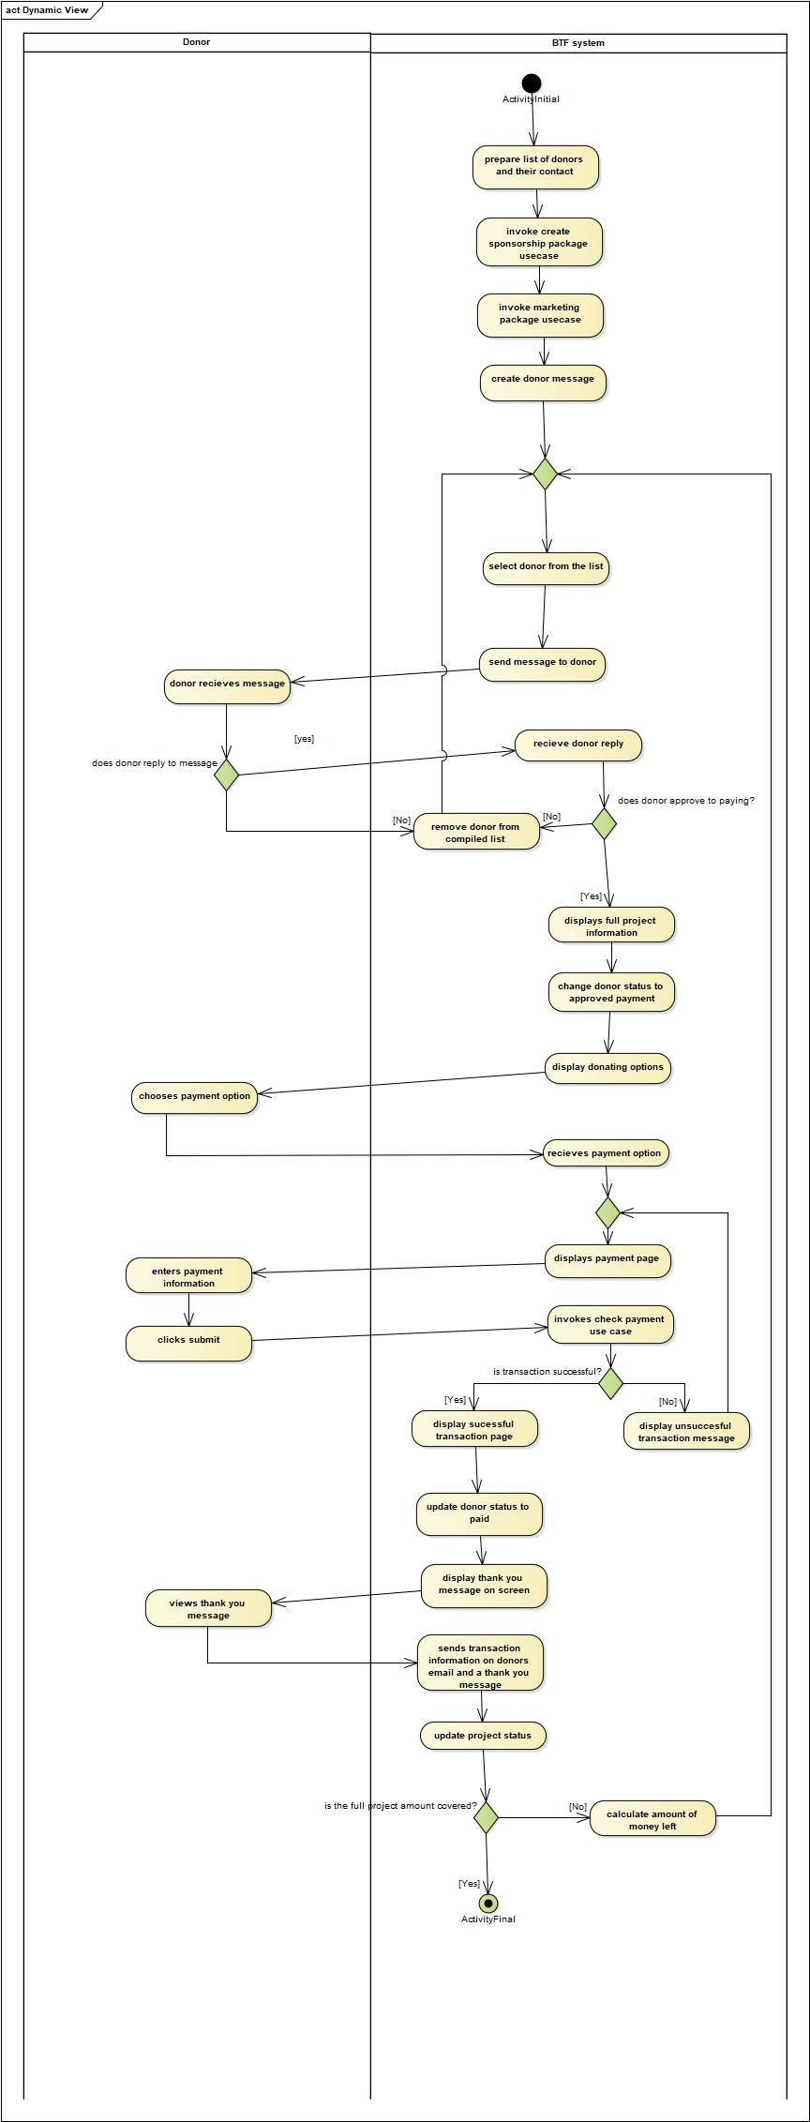

## Request Volunteers – Maryam Salah

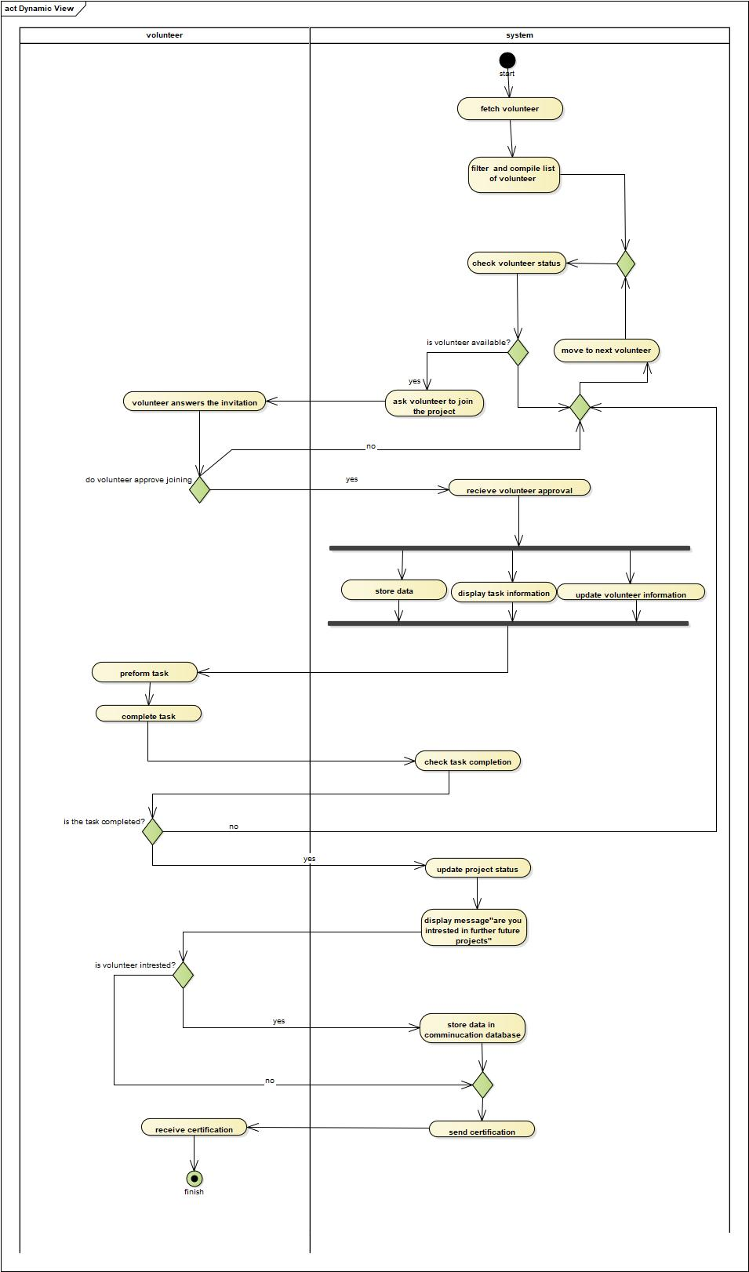

## Create New Project – Maryam Aqeel

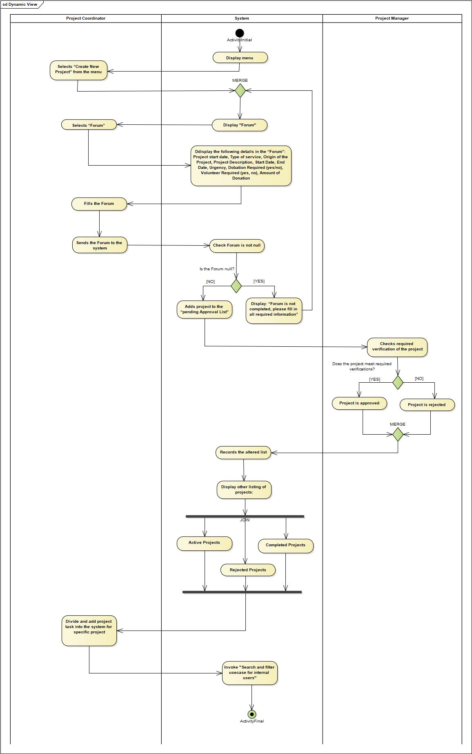

## Registration/Sign Up – Fatima

# Potential Object List

|  |  |  |  |
| --- | --- | --- | --- |
| **Potential Object** | **Notes** | **Object** | **Reason** |
| Dashboard | Customized for each user, | X | Not correct name for object |
| Department | The sector employees work in | X | Jobs are specified |
| Project Proposals | Has the projects main idea etc. | Yes |  |
| Project budget | Has the projects money spending | Yes |  |
| Project contract | Official signed document between admin and project owner | Yes |  |
| Surveys | Specific for a particular problem, outcome | Yes |  |
| Agreement | Has the official agreement | X | Part of the contract |
| Volunteer | Contains information about the volunteer contact info, availability and so on | Yes |  |
| Donor | Contains information about the donor contact info, availability and so on | Yes |  |
| System | The overall system behaviors | X | Not a correct name for object |
| Urgent case | Contains information about how urgent the case | X | Attribute of project |
| Portal | Web based- browser | X | Not related |
| Hardware | The devices that host the system, backbone | X | Not correct name for object, not an object |
| Machine | The devices that host the system, backbone | X | Not correct name for object, not an object |
| Project delays | How far a project is delayed | X | Attribute of project |
| Project | Contains info about project, when it started, how much it needs to finish etc. | Yes |  |
| Staff | Type of employees that enter the system | Yes |  |
| Users | Type of users that enter the system | Yes |  |
| Admin | Employee that manages projects and maintains the system | Yes |  |
| Username | The username of the user | X | Attribute of User |
| Password | The password of the user | X | Attribute the password |
| Email | Email sent to any type of user for a specific cause | X | Attribute in contacts |
| Project start date | Start date of a project | X | Attribute of project |
| Type of service | Type of service the project provides | X | Attribute of project |
| Origin of project | Origin or the project registered | X | Attribute of project |
| Project description | Brief about project motive | X | Attribute of project |
| End Date | When will the project end | X | Attribute of project |
| Donation required | Are donors required | X | Attribute of project |
| Volunteer required | Are volunteers required in projects | X | Attribute of project |
| Approval list | List of approved projects | X | Already there in project status |
| Project status | List of complete, active and rejected project | X | Attribute in project |
| Project Coordinator | Person in charge of adding | Yes |  |
| Project task | Part of the project | X | Attribute of project |
| Sponsorship package | Details of how the donor can sponsor the project | Yes |  |
| Marketing opportunity | The marketing that includes the project and the sponsorship package | Yes |  |
| Contact information | The users social details | Yes |  |
| WhatsApp | Number that user uses | X | Attribute of contact information |
| SMS | SMS of user | X | Attribute of contact information |
| Partial payment | Type of payment | X | attribute of payment – payment type |
| Full payment | Type of payment | X | Attribute of payment – payment type |
| Payment | The types of payment the donor | Yes |  |
| Volunteer availability | Whether volunteer is available or not | X | Attribute of volunteer |
| Certificate | Thank you, certificates, sent after volunteer does | Yes |  |
| Project Manager | Person who manages projects | Yes |  |
| Reports | Document that provides insight on statistics | Yes |  |

# Proposed Object List

|  |  |
| --- | --- |
| Project Proposals | Has the projects main idea etc. |
| Project budget | Has the projects money spending |
| Project contract | Official signed document between admin and project owner |
| Surveys | Specific for a particular problem, outcome |
| Volunteer | Contains information about the volunteer contact info, availability and so on |
| Donor | Contains information about the donor contact info, availability and so on |
| Project | Contains info about project, when it started, how much it needs to finish etc. |
| Staff | Type of employees that enter the system |
| Users | Type of users that enter the system |
| Admin | Employee that manages projects and maintains the system |
| Reports | Document that provides insight on statistics |
| Project Coordinator | Person in charge of adding |
| Sponsorship package | Details of how the donor can sponsor the project |
| Marketing opportunity | The marketing that includes the project and the sponsorship package |
| Contact information | The user’s social details |
| Payment | The types of payment the donor |
| Certificate | Thank you, certificates, sent after volunteer does |
| Project Manager | Employee who managers projects |

# Analysis Domain Class Diagram for whole system

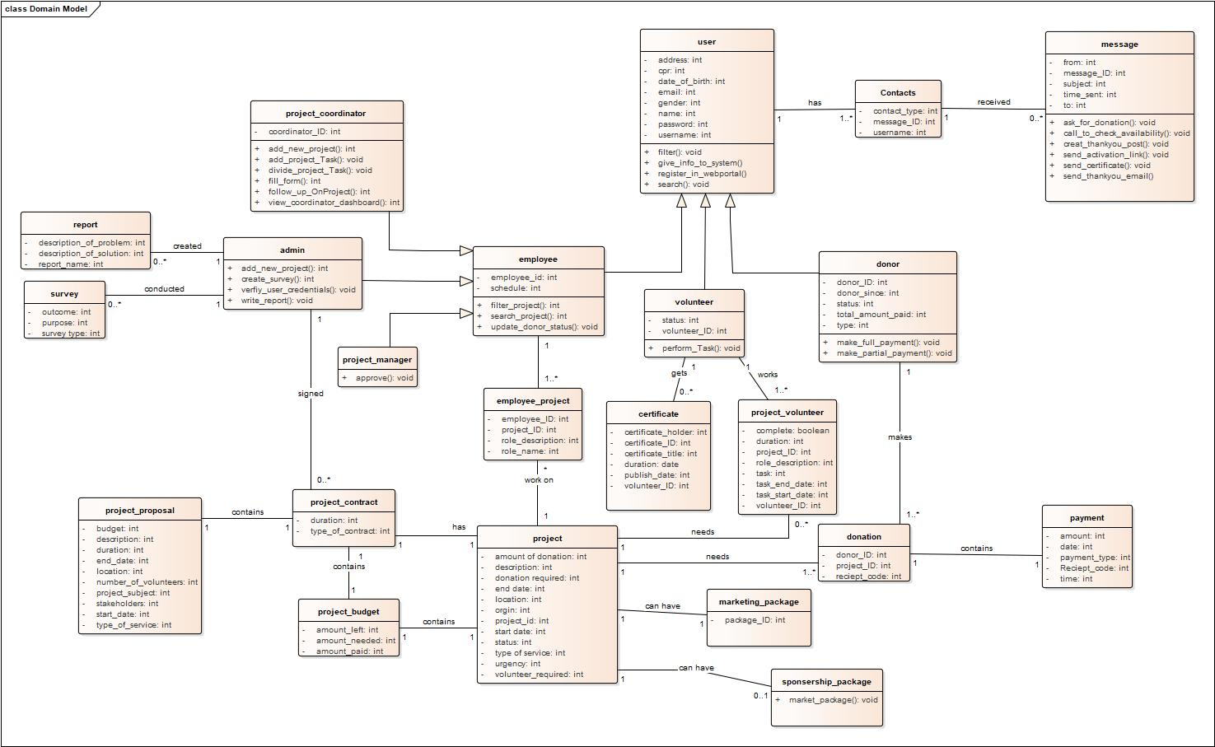

# Cost/Benefit Analysis

## Net-Present Value

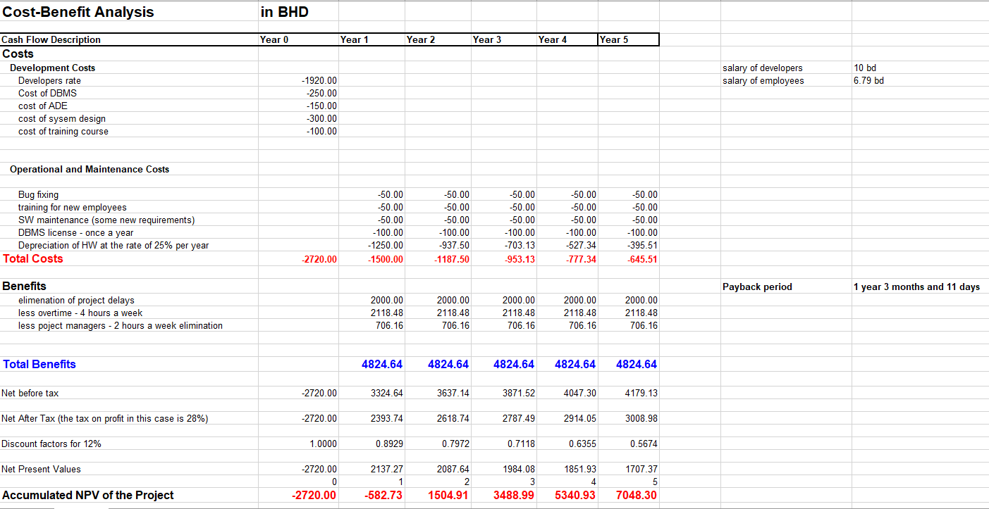

## Payback Period

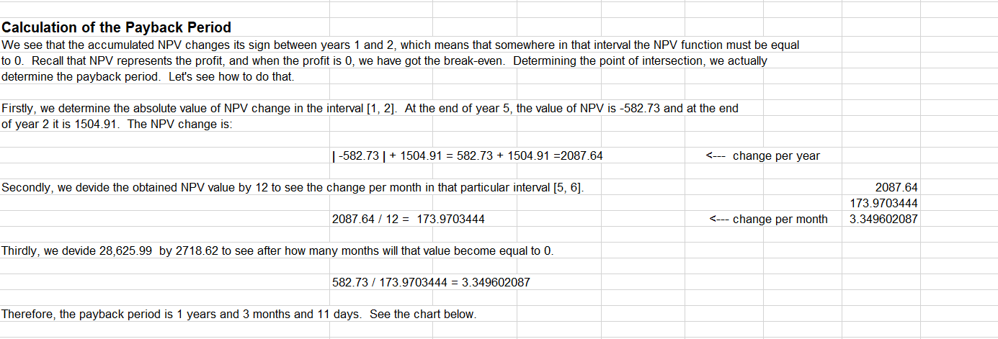

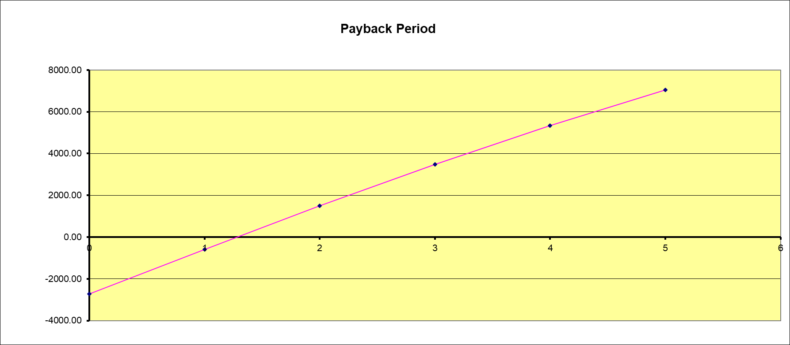

Break Even Point

# State-chart Diagram

## Project – Maryam Aqeel

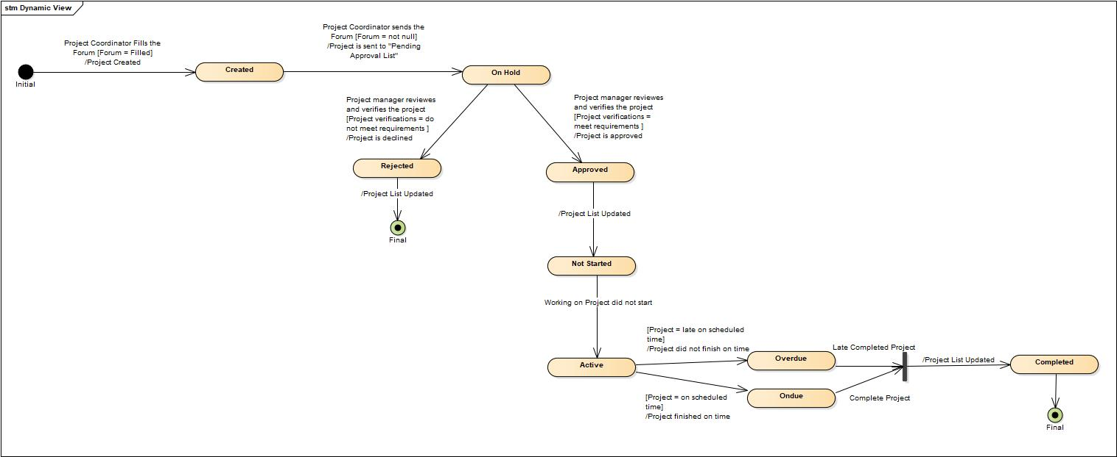

## Task – Fatima Nasser

## Volunteer – Maryam Salah

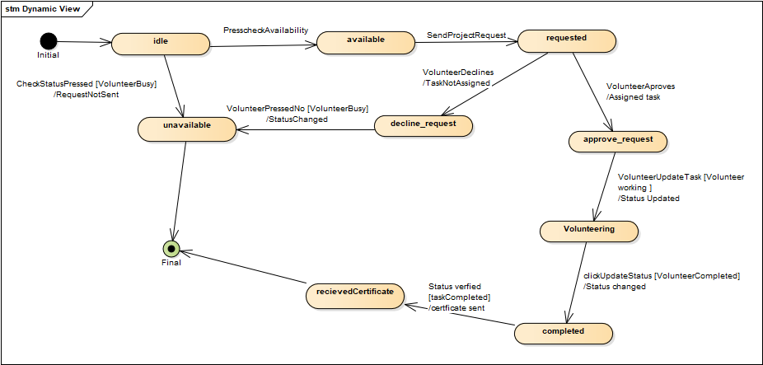

## Donation – Noora Qasim

# Sequence Diagram

## Request Donation – Noora Qasim

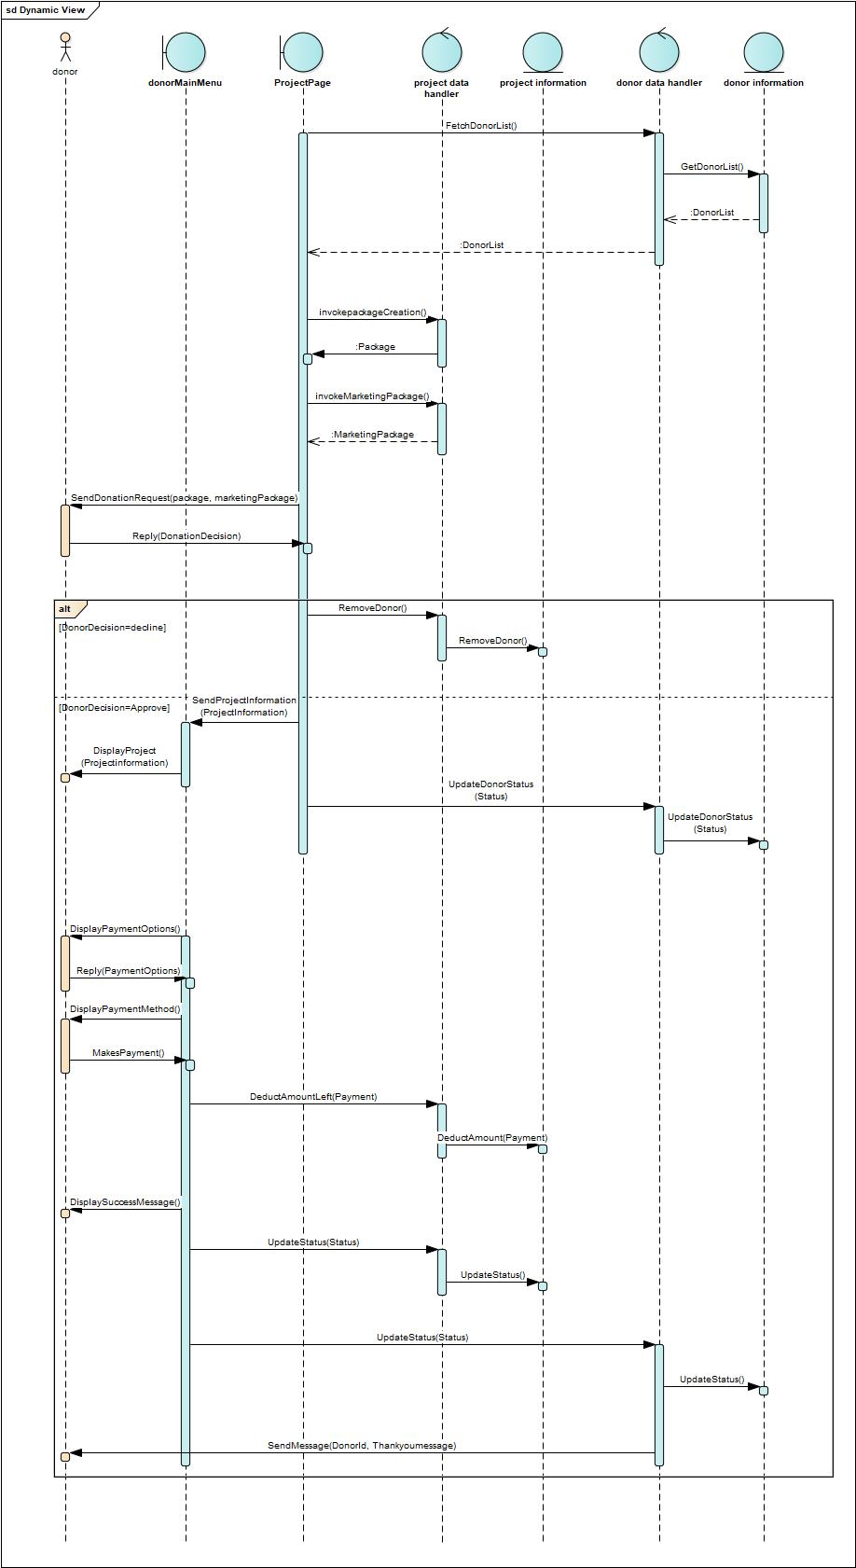

## Request Volunteers – Maryam Salah

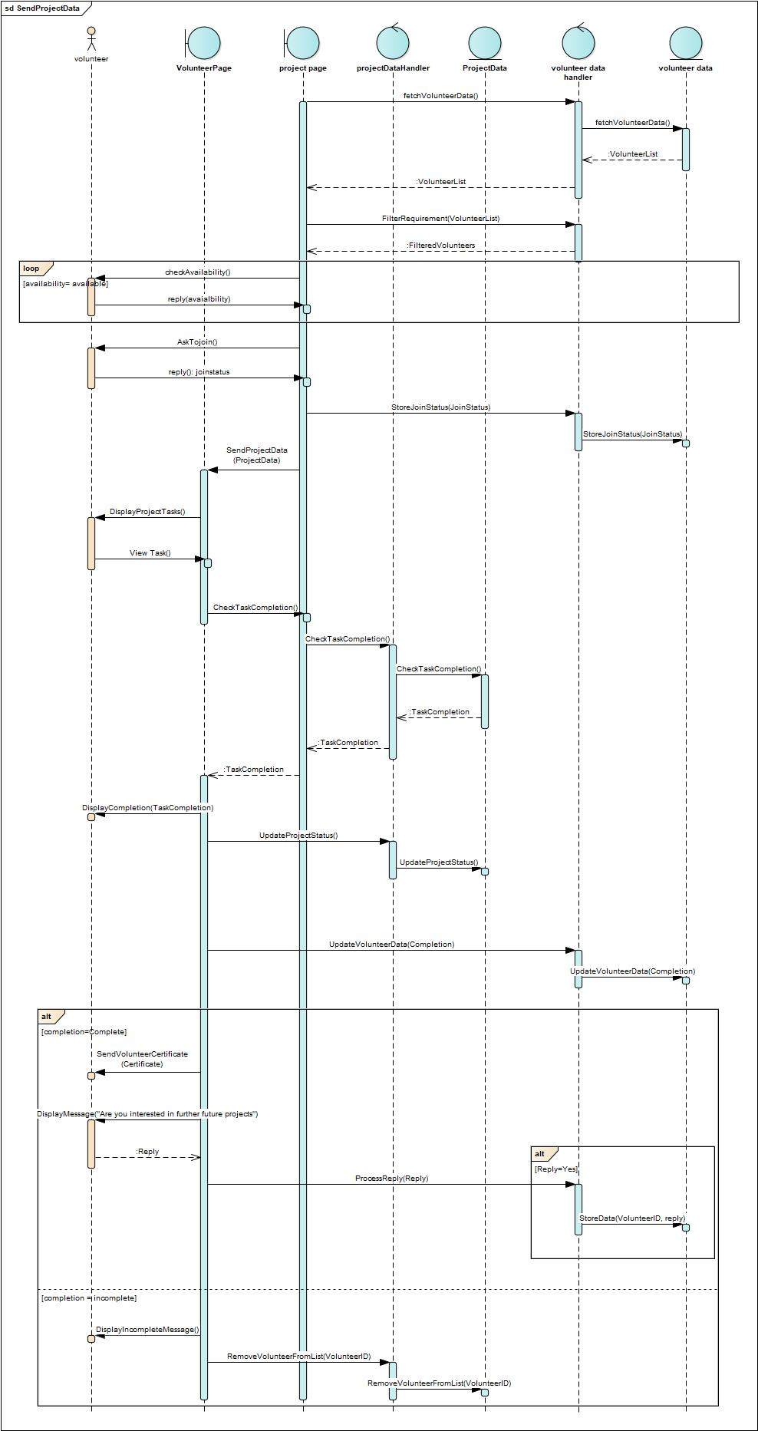

## Create New Project – Maryam Aqeel

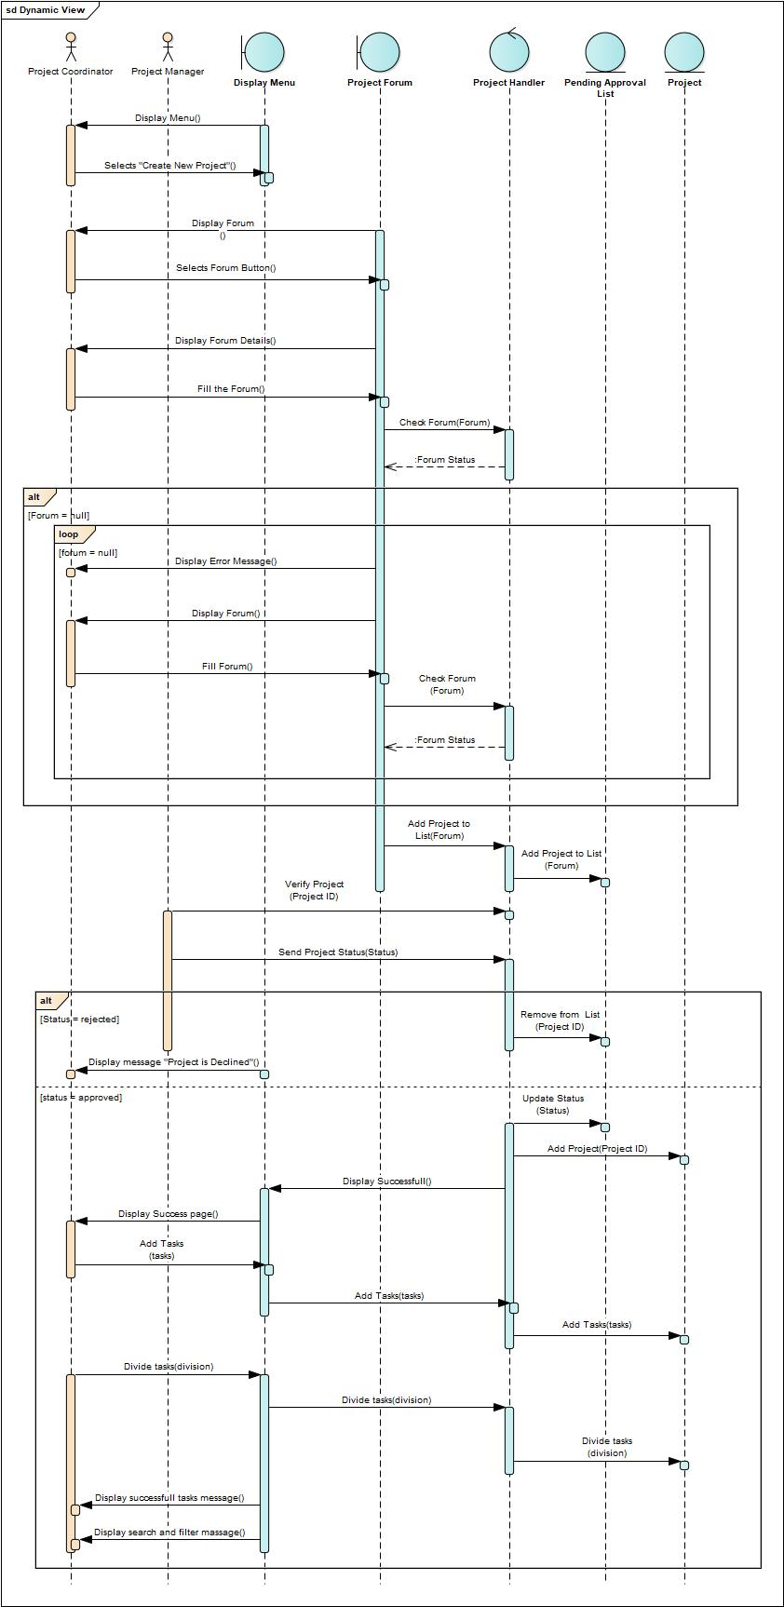

## Registration/Sign Up – Fatima Nasser

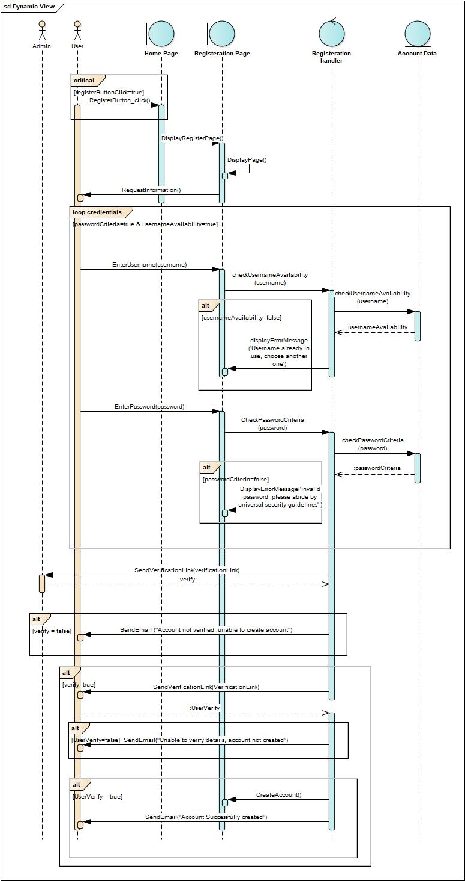

# Interview Form

|  |  |  |
| --- | --- | --- |
| **Interviewee:** Mrs. Saba  **Date: 14.11.2022**  **Time: 8:00am**  **Place: Building 5 room 06**  **Subject: BTF primary interview** | | |
| **Time Allocated** | **Interviewer questions and objective** | **Interviewee**  **Response** |
| 1 - 2 minutes | **Objective**  Open the interview   * Introduce ourselves * Thank Mr. X for his valuable time * State the purpose of the interview |  |
| 2 minutes | **Question1:** When mentioned the lack of data about data, what data was meant  **Follow up** |  |
| 1 minute | **Question2:** are the employees trained to work on a Microsoft SQL server  **Follow up:** how about oracle 21c |  |
| 2 minutes | **Question3:** How long is the time allocated for the project completion  **Follow up** |  |
| 3 minutes | **Question4:** Do you have an expected breakeven point?  **Follow up: how much are the overtime salaries** |  |
| 3 minutes | **Question5:** What is the main issue you face that leads you to be unaware of the costs and maintenance of the new system  **Follow up** |  |
| 3 minutes | **Question6:** system development: should the admins also have a customized dashboard  **Follow up:** is there no login page? Only register |  |
| 4 minutes | **Question 7:** do you need the volunteer page to display how many volunteers are needed for each project, why is it not mentioned  **Follow up:** does that system need to verify if the volunteer is incapable of handling any project, take them off the list, what are the verifications for both system and project |  |
| 1 minute | **Question 8**: Does the system keep track of the volunteer completion rate? |  |
| 1 minute | **Question 9:** What is the hardware depreciation rate |  |
| 1 minute | **Objective**  Conclude the interview   * Thank Mr. X for his cooperation and help. * Assure Mr. X that he will receive a copy of a letter summarizing the interview |  |
|  | Time allocated for questions and objectives |  |
|  | Time allocated for follow-up questions |  |
| 25 minutes | Time allocated for interview |  |

# Log Files

## Log 1

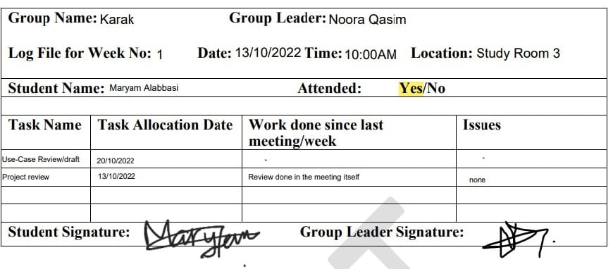

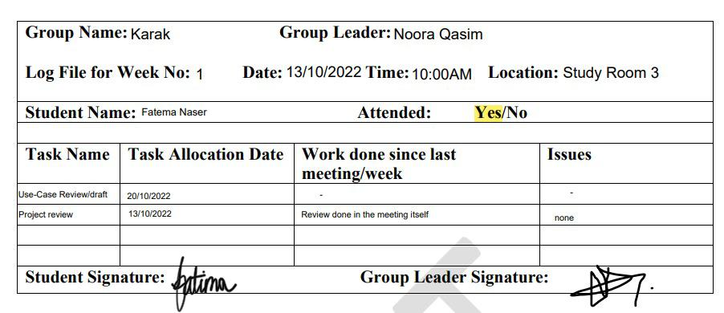

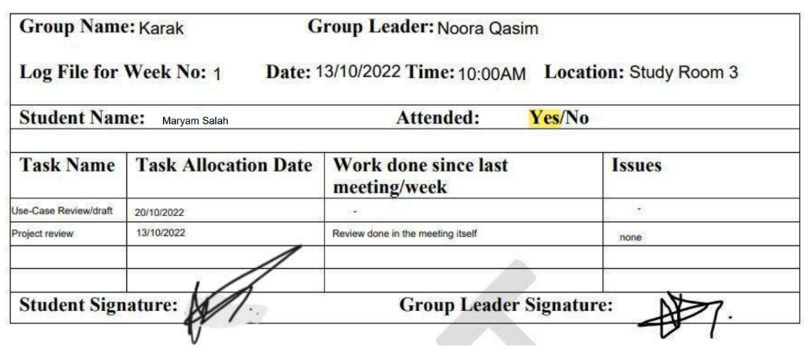

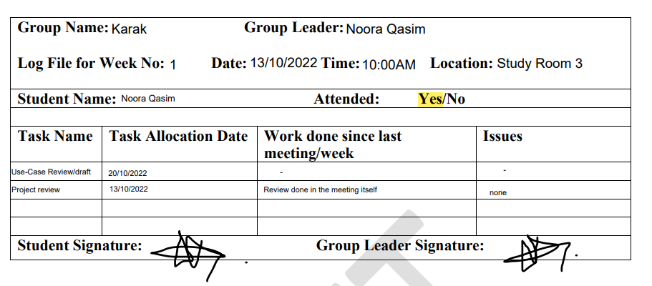

## Log 2

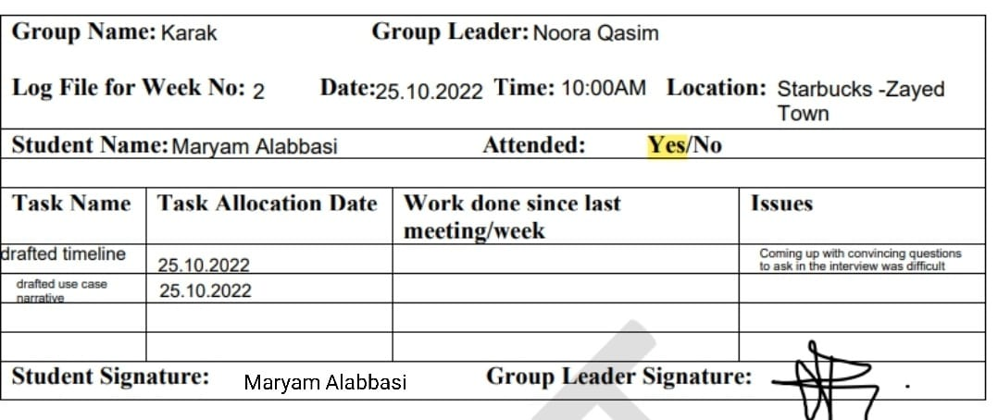

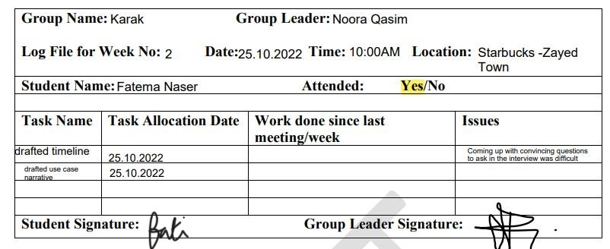

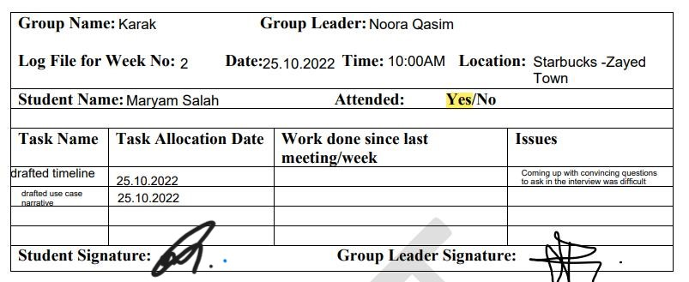

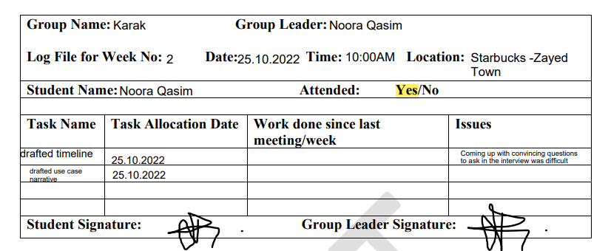

## Log 3

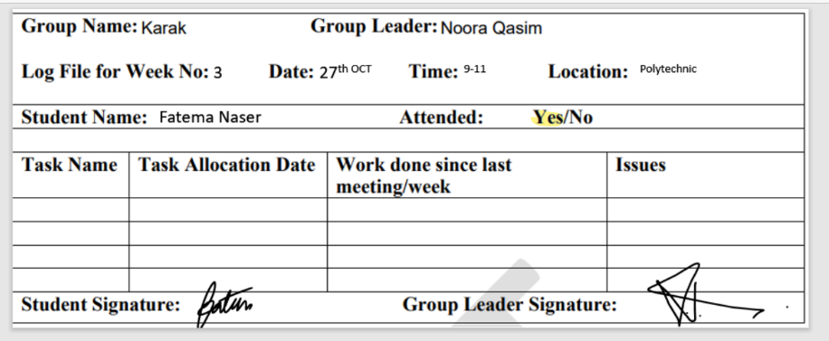

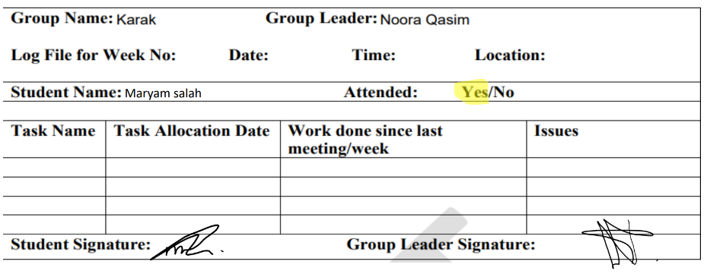

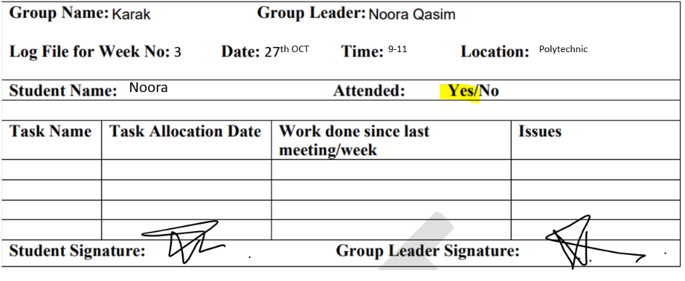

## Log 4

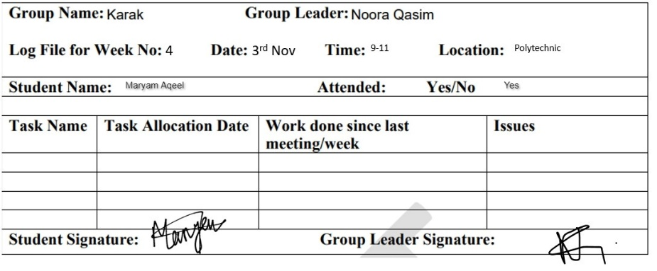

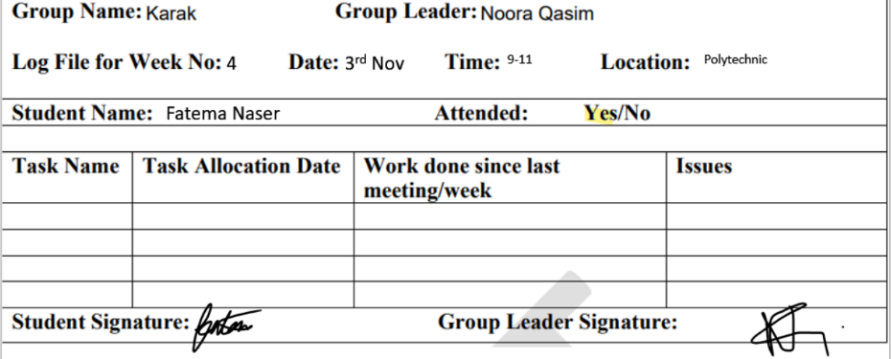

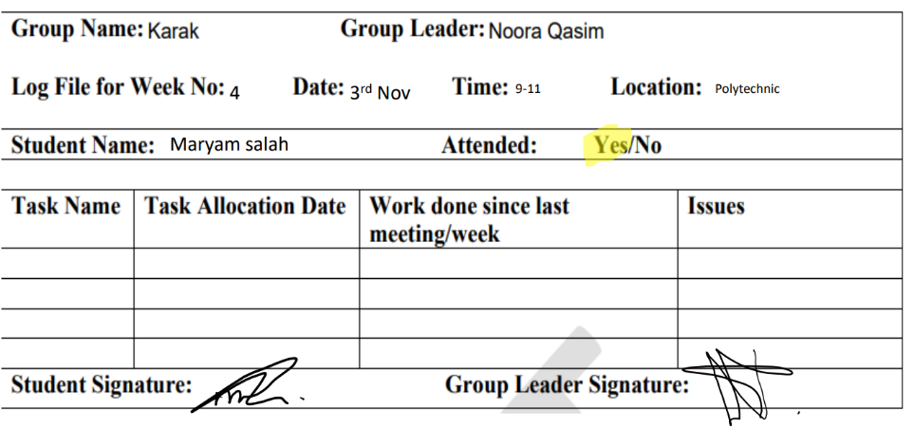

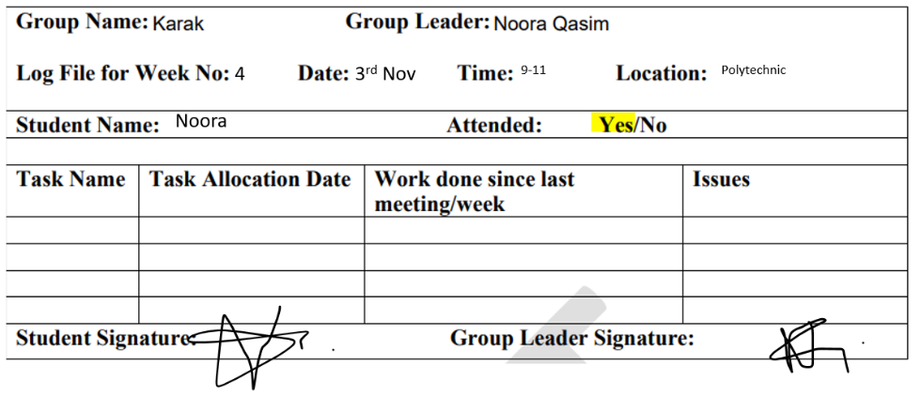

## Log 5

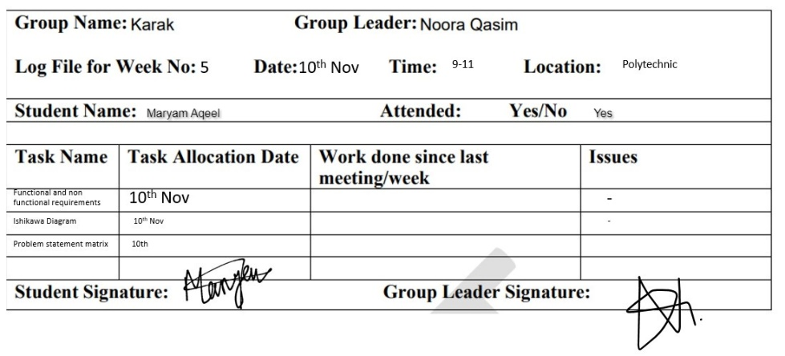

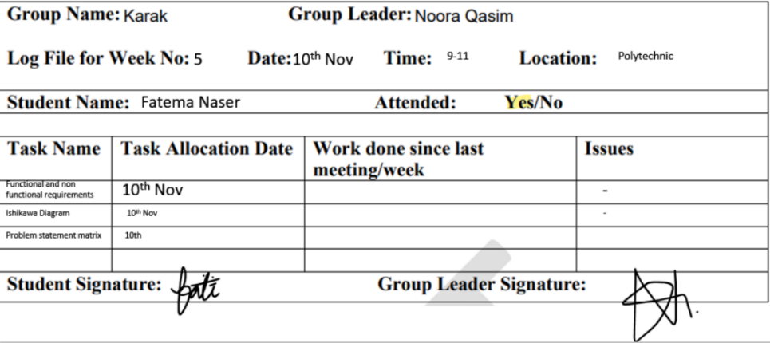

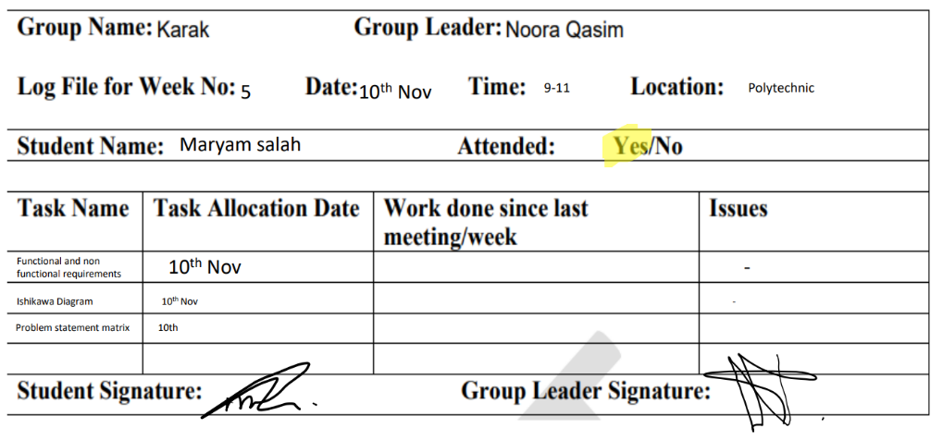

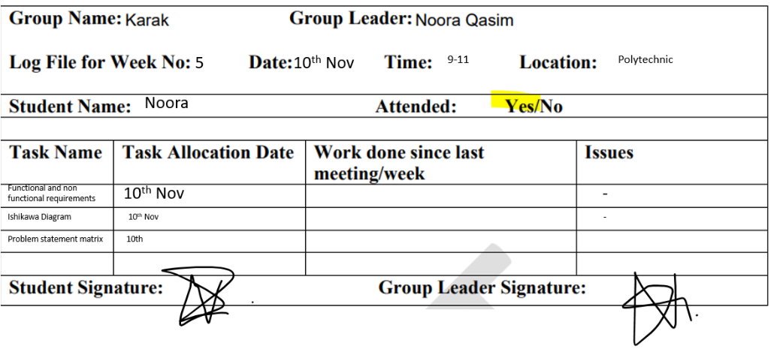

## Log 6

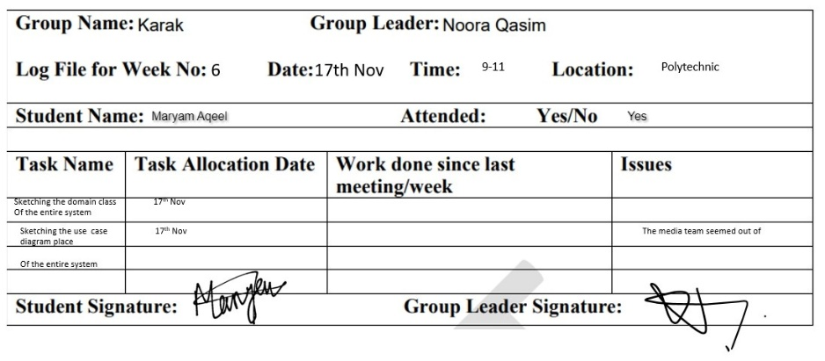

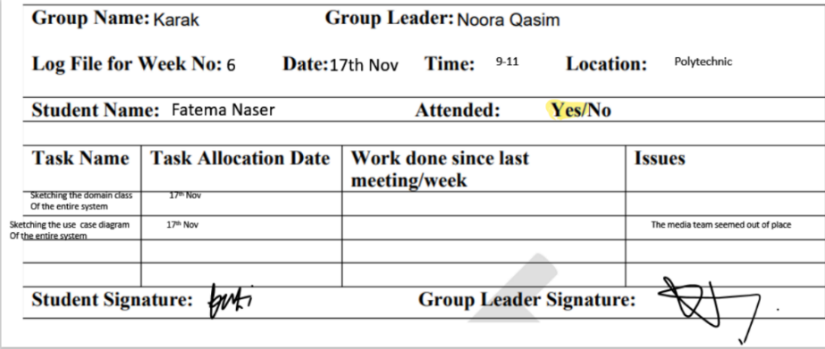

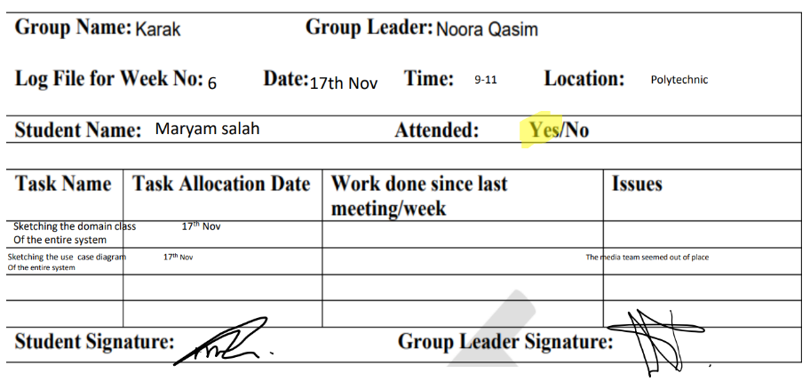

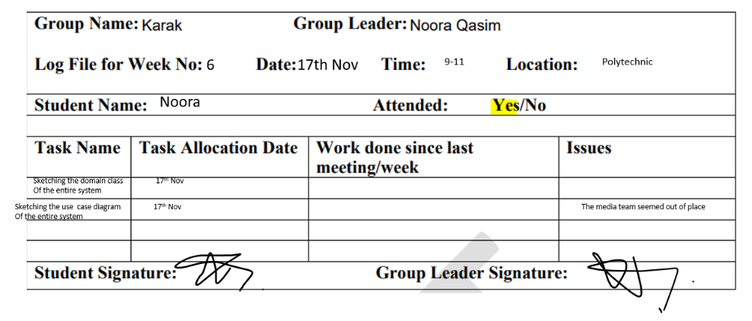

## Log 7

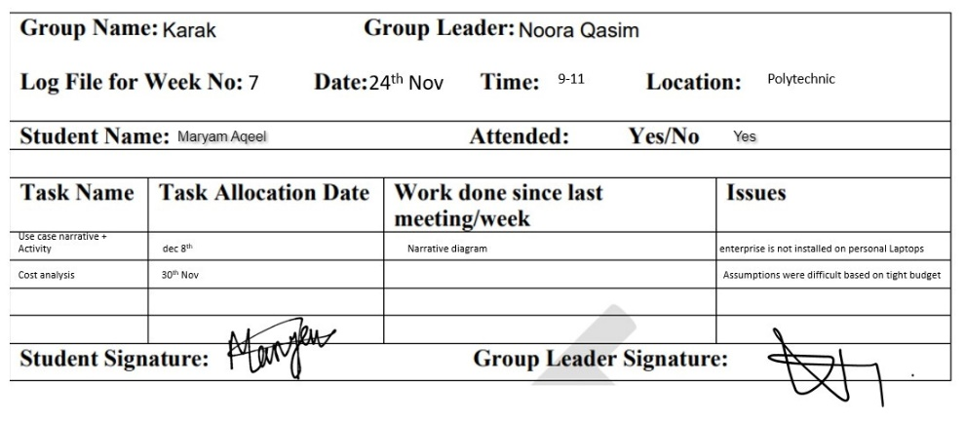

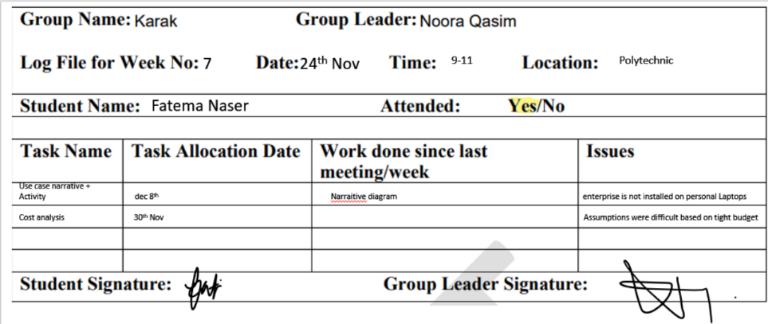

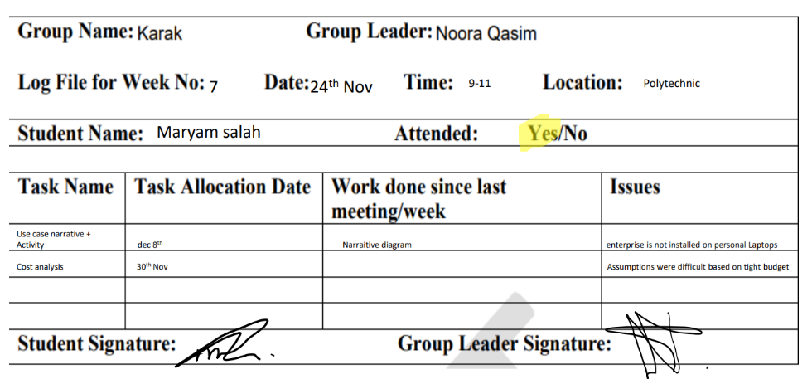

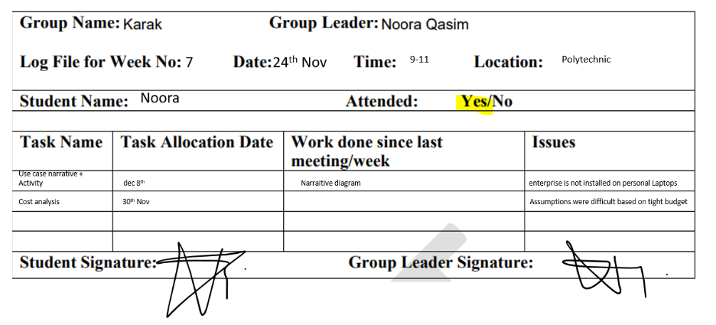

## Log 8

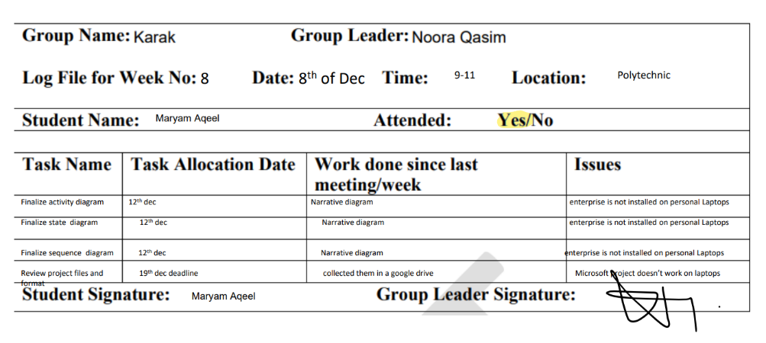

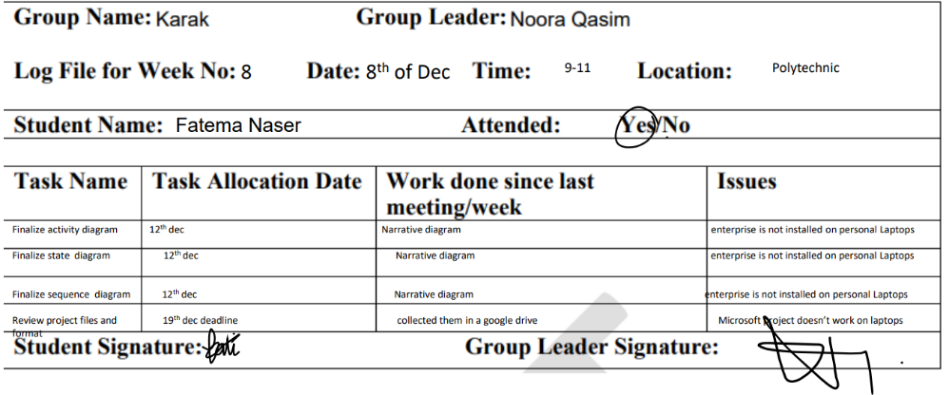

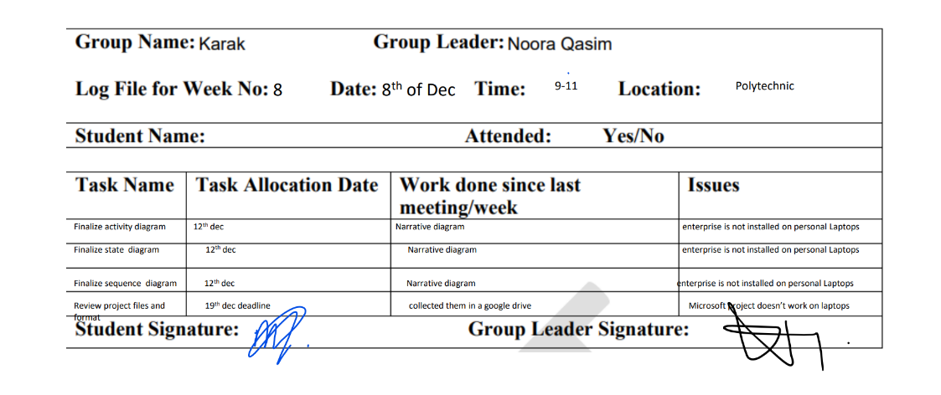

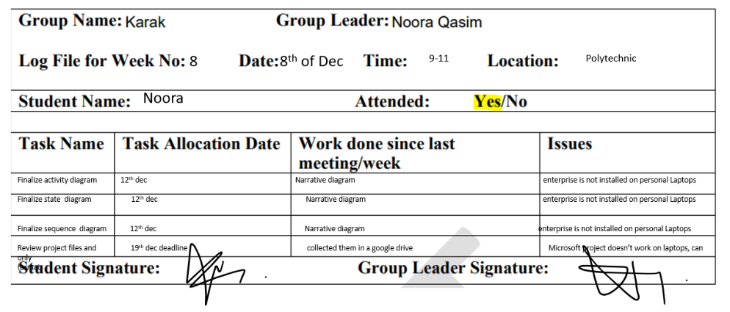

# Individual Report

## Fatima Naser – 202102290

In this report we will be reflecting on the time we worked on this project, it is all based on personal experience and the problems we faced, how we faced them, how we found solutions and moved forward and learnt. In every experience we learn and grow and prepares us to face our next steps.

When the project data was first presented to us, me and my team had trouble understanding what was asked from us, what were we asked to do, mainly because we did not cover everything that was being asked from us yet, so the information gathering phase was slower than the rest of the phases. Not only that, all the information seemed redundant and repeated, but after carefully reading and analyzing the case study, we realized how the information is extremely similar and different from each other and where each piece of information mattered and where it should be used. Furthermore, our team had trouble making assumptions where we should. We did not really know the line between making assumptions and making stuff up, but soon that line seemed clearer after a few classes. During our first few meetings, we also had trouble focusing on the subject, we always deviated from the subject which made our meetings longer and not productive enough, however later we started adapting and things went smoothly, and we did more each meeting. In addition, there is a lot of information missing from the project file, so we had to make assumptions and ask about them in the interview.

In the designing phase, the first problem we faced was not having the applications (enterprise architect, Microsoft Visio) on our personal laptops, so the only way to work on the project was using the university’s devices. We also could not find common time between our schedules and our personal lives, so to compromise we had to spend more time working after our classes and staying late in university. We found a solution to this problem by creating and using google calendar with our schedules to find a time when we all are free to work. When we had our meeting, each one of us had different views, ideas, and approaches about how we should go about with our project, in the end we came to the middle ground.

When we came to finalizing the project, we had a tough time collecting our work together like different diagrams and our Indvidual work. To solve this problem, we used OneDrive to put all our work in it and check everything as a finalization for the project to submit it.

Overall, I think that many things could have been done better like adding more useful interview questions that will help us understand the requirements better. When moving forward to the next phase, further problems may be faced in the organization, for instance they may have extra requirements after the completion of the system design, which may require us to restart some of the phases of the system design.

 In conclusion, we have faced many problems and learnt how to overcome them. It certainly was a new and challenging experience to work on a project that is long term (8 weeks) and requires constant updates. We also learned many lessons from this experience as system analyst, those lessons will certainly be helpful and useful for us in our future steps and projects.

**Reference**

Group Work. (2022). Retrieved December 22, 2022, from Harvard.edu website: <https://bokcenter.harvard.edu/group-work>

## Maryam Aqeel – 202103328

This report is going to critically evaluate and reflect my individual experience and performance through the time and process of doing system analysis and design’s project. It will discuss issues I have faced during the project and the way of solving them, as well as reflecting on the learning acquired throughout the different phases, also it will state things that I will change in the future while working on the project, and it will draw a conclusion with the outcomes of the project.

Issues and challenges are part of the learning journey of any project, since they are what make us learn. There were many challenges while doing the project, the first one is that the software used: Microsoft Visio, MS Project, and Enterprise Architect are not available all the time. These softwares are only available at the campus, which means that we only can work on them within the working hours. As a solution, I searched online for a cracked version of Enterprise Architect and downloaded it, so I can work on my diagrams any time. Regarding Microsoft Visio and MS Project, my team members and I worked in our breaks or stayed at the campus after the end of our classes to complete the work. An additional challenge was designing the actual UML diagrams in Enterprise Architect, especially the sequence diagram, since it is considered the lengthiest diagram. The Sequence Diagram demonstrates the flow of messages during an interaction between objects. A group of objects that are represented by lifelines and the messages they exchange over the course of an interaction make up a sequence diagram. Because of all the interfaces, actors, and use cases sequence diagrams have, I faced some difficulty with designing it, but with practice and studying, it became easier to do it. All these issues and challenges affected the final results, but did not affect a large percentage. Their impact was in the short term, as some deliverables were delayed beyond the deadline that I had set for them, but in the end I was able to finish them all within the time specified for the project.

If I had the chance to redo the project again in the future, I will change many things. First, I will download the cracked version of Enterprise Architect before working on the project, so I get used to it, also because it will save me time instead of working on the diagrams at the campus. Working on this project broadens my perspective while also allowing me to examine a company's operations from all angles. One of the most challenging things I had to consider while working on and building the UML Diagrams was taking into account all the staff in various departments.

Working on this project also taught me how important having a plan and a clear idea of what you want to accomplish and when. I have gained the necessary skills to work in a team after this project. I have learned how to communicate with team members since communication is the foundation of effective teamwork. Also, I gained time management, problem solving, listening, critical thinking, collaboration, and leadership skills. Burke (2011) had mentioned that group work can improve "time management skills, active listening, evidence of cooperative behavior, and professionalism and engagement with the task".

**Reference**

Burke, A. (2011, November 02). Group work: How to use groups effectively University of North ... Retrieved December 19, 2022, from <https://uncw.edu/jet/articles/vol11_2/burke.pd>

## Maryam Saleh – 202100106

The information gathering phase of our project required us to hold a meeting to read the project and define the requirements. We struggled first into understanding the study case and what is required, we had to hold many meetings to discuss the requirements and what should we start doing first, to do that we implemented a full schedule for the tasks that should be done before starting anything by the help of MS project which made things more organized. When things appeared to be going well because the group was having fun, the conversation could veer off topic, wasting time and delaying the completion of the goal we had set in this meeting. As well as, confusing the meeting’s purpose. We had to designate someone to keep track of the time for each task we had to complete in order to solve this issue. Moreover, Group members had different schedules which made it hard with completing the group work and this messed up some of our project schedule plan that we had in mind to in completing the tasks. We used to google calendar to find a time where all the members are free to set a meeting and complete tasks.

Many assessments and project submission were due before this project, so the focus mostly was to them which made us delay some of our tasks but soon after we were done, we managed to be back on track again by dedicating a full day to finish what we delayed.

As for the designing phase, one of the problems we faced was Conflict or a difference of opinion as it is one of the common problems in projects (Flint, 2016). it was challenging because we got to know different point of views on how the designing part should be done. Handling this conflict of opinions was tough because at the end we had to choose one opinion when all of them made sense. We had to make a voting if there was different opinion which solved the problem.

One of the main problems we faced was that we couldn’t use the campus due to the national day holiday which made us unable to use Enterprise architect. This caused a problem in our schedule and to fix this problem we stayed on campus and finished our work. As well as we downloaded the application in our laptops to finalize our individual work.

Things that could’ve been done better was the interview. After the interview was done, we started working more in details with the project, so more details seemed to be missing, I think it would’ve been better if we did more than 1 interview, one before we start and the another is halfway through working in our project, to get more information about the requirements and user’s needs. In addition, the explanation of the sequence diagram was at the end of the course, so we didn’t have time to practice it before implementing what we’ve learned in the project, I think it would’ve been better if we practiced more to know our common mistakes and learn from them.

In conclusion, this project provided us with a lot of knowledge on how to properly handle a long term project. It had shed light on issues that are not visible to the outside eye and can only be experienced when in progress. It is believed that this project is very beneficial for the students’ progress throughout their ICT journey.

**Reference**

10 Common Problems Project Teams Face | Challenges & Solutions. (2016, August 11). Retrieved December 22, 2022, from Apm.org.uk website: https://www.apm.org.uk/blog/10-common-problems-project-teams-face/

## Noora Qasim – 202103422

The Group project for the System Analysis and Design was to design and plan a new web-based solution for the Bahrain Trust Foundation to conquer its needs. This report will discuss how the different phases of the system development life cycle went and how it could be improved on.

The main issues we phased during the information gathering process was that we had minimal knowledge of the idea of the project and its deliverables, and because there were parts that were not yet covered, we faced an issue with understanding what we need to know about them. However, by time and the more understanding of the deliverables this issue was solved. In addition, we believe that a second interview could have helped a lot in the understanding.

During the analysing and designing phases because some parts require the entire group to be present, we found it difficult to find a long period of time where we were all available and settled on a 2-hour break on Thursday, which delayed our progress rate. Moreover, the group tend to get distracted with other topics during the discussion and lose sight of the main aim, thus furthering our progress more.

Another main issue to be phased was that the students did not have access to the software applications needed to implement the project on their personal computers. Thus, limiting the meeting spaces to the university campus specifically the labs with enterprise architect installed. Finally, the way we tackled this issue was to find cracked versions of the software and work out the rest on campus. Moreover, there was a conflict of opinions that would not be resolved quickly causing time loss and lack of progression.

However, on the bright side we have eventually figured out a system where we could all work collaboratively and efficiently, increasing our completion rate and managing our work. We have decided to use one drive to effectively have an updated version of all the documents.

The main learnings of this journey include, working collaboratively as a team and finding teammates strengths and weaknesses from the beginning of the project. In addition, learning about the importance of time management and how it can be critical in delivering a project successfully. Moreover, proper task division is a vital aspect as well. In relation to a web-based solution, we learnt about the different types of databases and ADEs that could potentially create the perfect storing system.

Further issues that would be good to explore come with the further development of the process, how the diagrams can be implemented and how will they differ. Furthermore, exploring more projects that are extended through long periods of time can prove what we learnt throughout this process, where we can set clear goals and break down tasks in a successful manner because of the prior experience of this project. Moreover, the conversion of ideas can be done in a smoother way where we can create an environment to encourage the members and their respective point of views.

Overall, this project was a learning and challenging project to many students and it showcases areas of improvement and decline between teams. I believe this project was vital in enhancing the students’ knowledge and skills, in the course and their journey in the IT sector.

**Reference**

Group Work. (2022). Retrieved December 22, 2022, from Harvard.edu website: <https://bokcenter.harvard.edu/group-work>